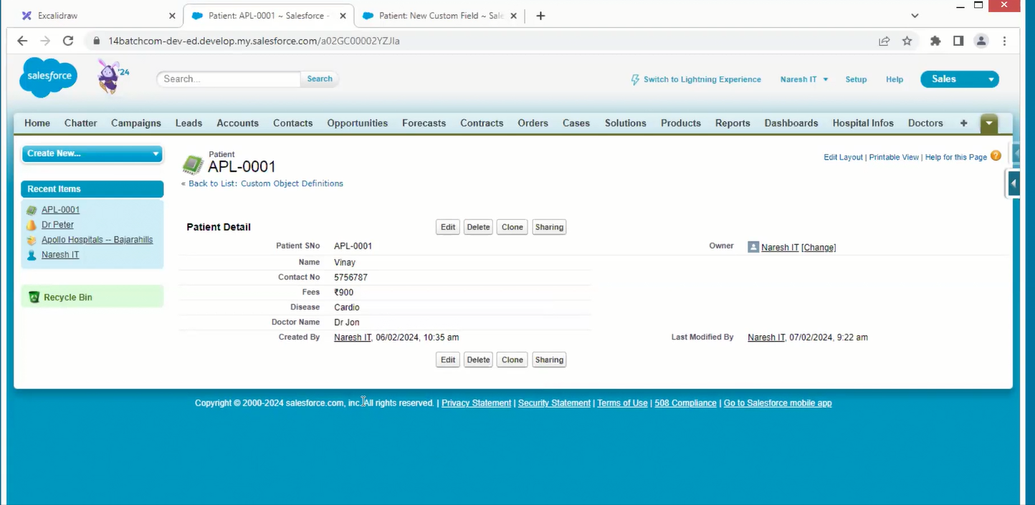

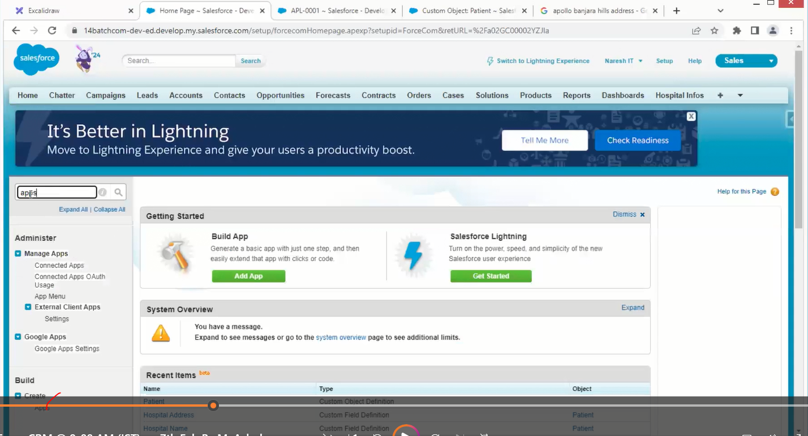

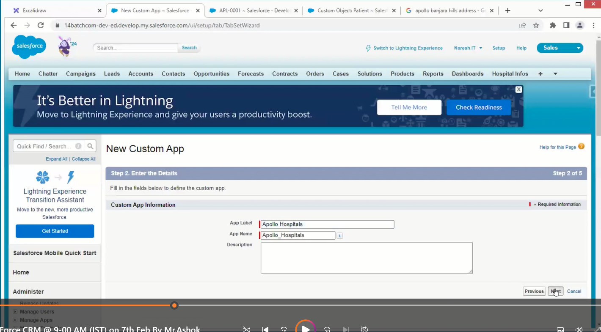

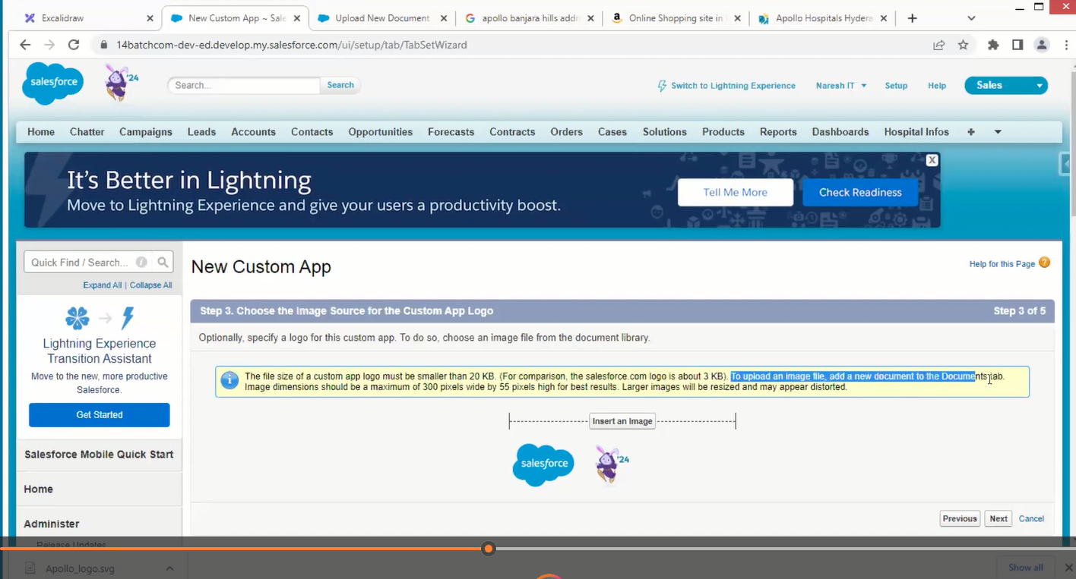

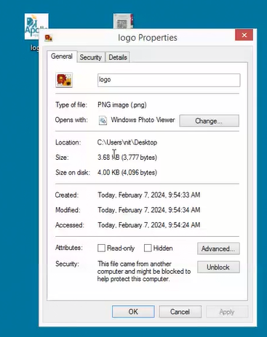

Every App have multiple Tabs

Every Tab has one object

Objects have multiple fields.

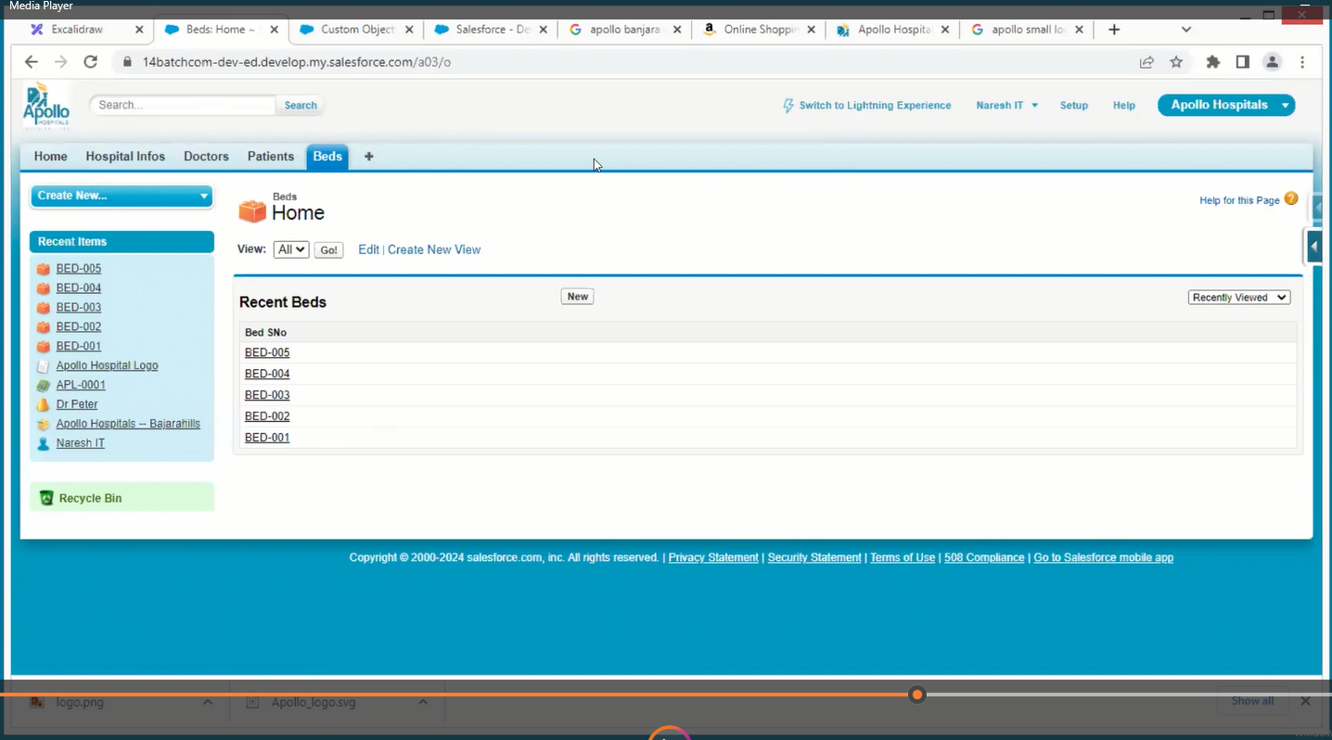

Now we need to know if it is efficient or not

This is a data model whether it is efficient or not, need to check.

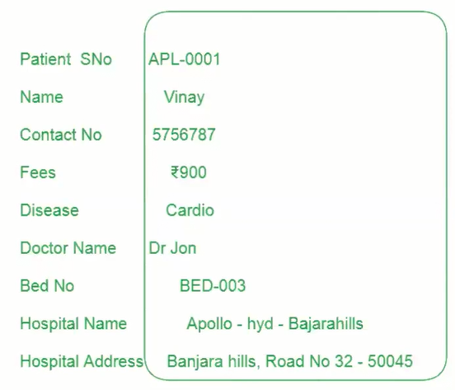

The above is one record of one person

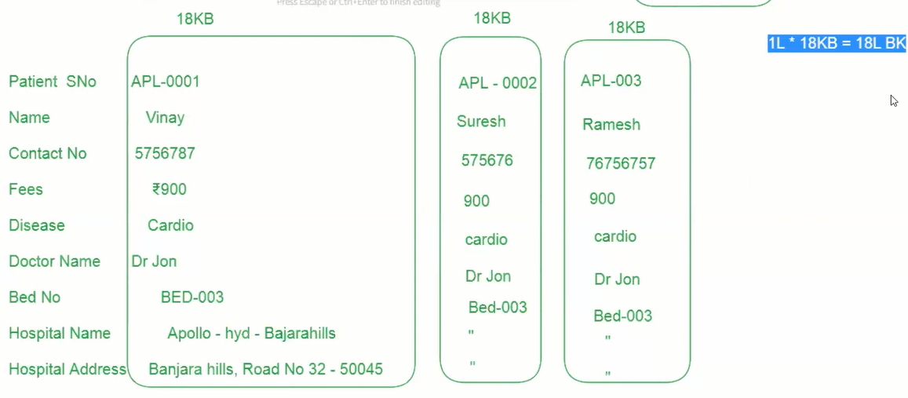

If data is increased the performance of the app decreases

In general, we will compress the data to zip file of lesser mb

